Task on Load Balancers
Q1 : Configure Classic Load balancer.

Step 1: Open Load Balancer Section
- Go to AWS Management Console
- Search for EC2
- In the left panel, click:
👉 Load Balancers
- Click Create Load Balancer

Step 2: Choose Load Balancer Type
- Select Classic Load Balancer
- Click Create

Step 3: Basic Configuration
- Name: my-classic-lb
- Scheme:
  - Internet-facing (for public access)
- Listeners:
  - Protocol: HTTP
  - Port: 80 → Instance Port: 80
Click Next: Configure Security Groups

Step 4: Configure Security Group
- Create a new security group or select existing
- Allow:
  - HTTP (Port 80) from Anywhere (0.0.0.0/0)
Click Next: Configure Health Check

Step 5: Configure Health Check
Set:
- Ping Protocol: HTTP
- Ping Port: 80
- Ping Path: /
- Response Timeout: 5
- Interval: 30
- Unhealthy Threshold: 2
- Healthy Threshold: 2
Click Next: Add EC2 Instances

Step 6: Register Instances
- Select your running EC2 instances
- Click Add to Registered
- Then Next

Step 7: Add Tags (Optional)
- Key: Name
- Value: CLB-Demo
Click Next: Review

Step 8: Review & Create
- Check all configurations
- Click Create

Step 9: Test Load Balancer
- Copy the DNS Name of the Load Balancer
- Paste it in browser:
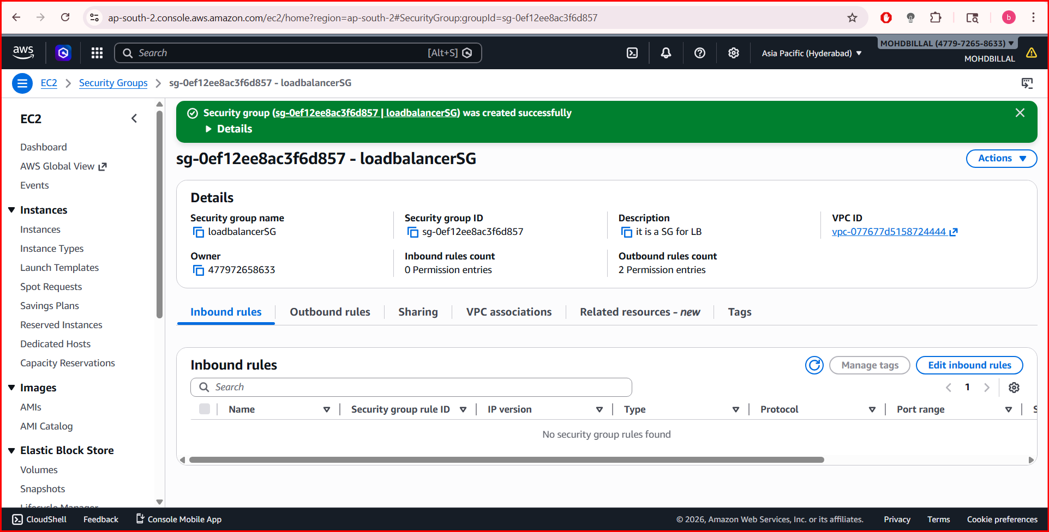
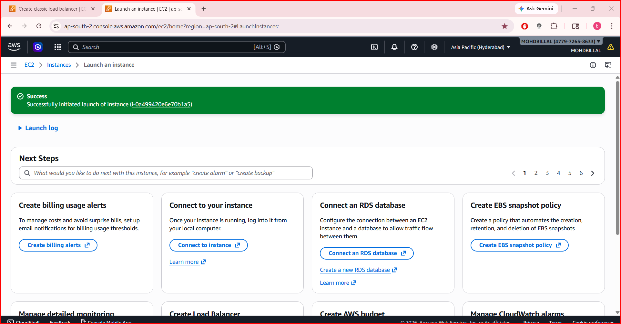
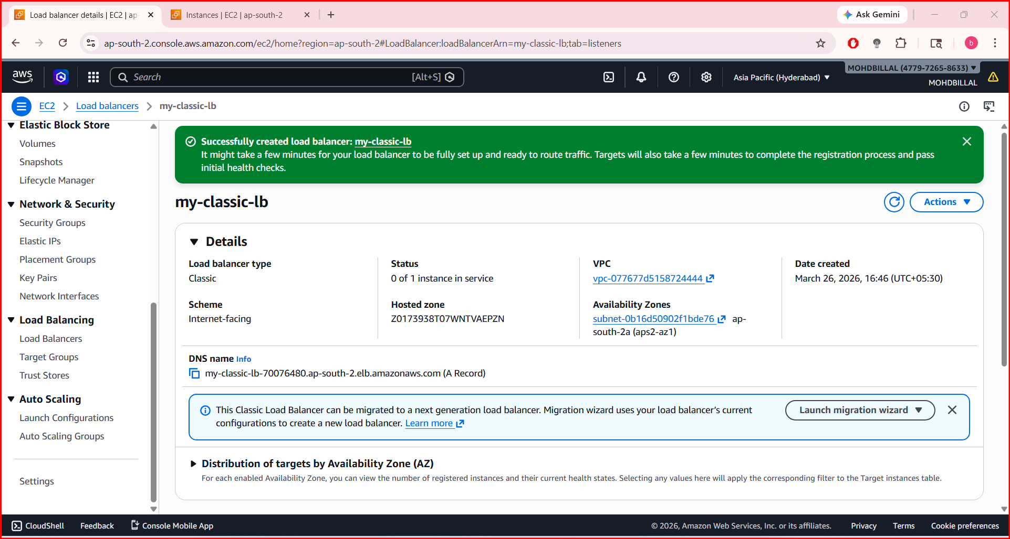
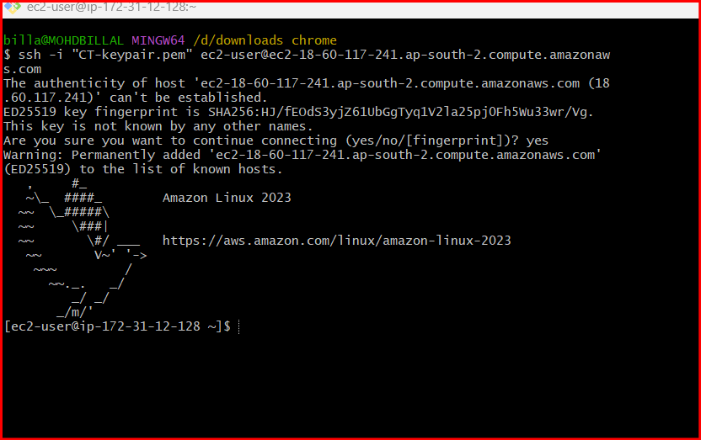
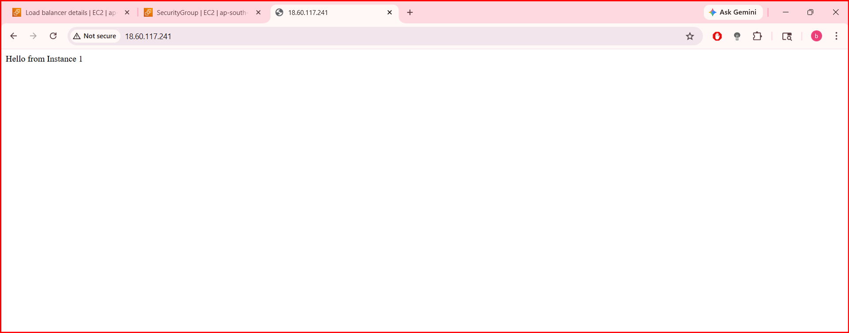
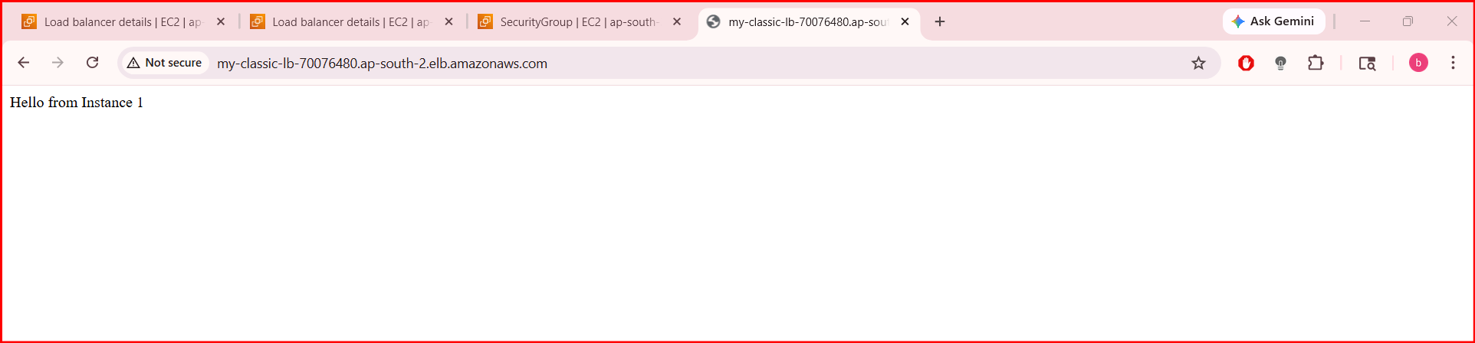
Q2. Configure Application Load balancer.

Step 1: Go to Load Balancer
- Open AWS Management Console
- Go to EC2
- Left side → Click Load Balancers
- Click Create Load Balancer

Step 2: Choose Type
- Select Application Load Balancer
- Click Create

Step 3: Basic Configuration
- Name: my-alb
- Scheme: Internet-facing
- IP type: IPv4

Listeners:
- Protocol: HTTP
- Port: 80

Step 4: Select Network
- Choose your VPC
- Select at least 2 subnets (different Availability Zones)
👉 Example:
- us-east-1a
- us-east-1b

Step 5: Security Group
Create or select one:
- Allow:
HTTP (80) → 0.0.0.0/0

Step 6: Configure Target Group
Click Create Target Group

Settings:
- Target type: Instances
- Name: my-target-group
- Protocol: HTTP
- Port: 80

Health Check:
- Path: /
- Protocol: HTTP
👉 Click Next

Step 7: Register Targets
- Select your EC2 instances
- Click Include as pending below
- Click Create Target Group

Step 8: Attach Target Group to ALB
- Go back to ALB creation
- Select your target group
- Click Create Load Balancer

Step 9: Test ALB
- Copy DNS Name of ALB
- Open in browser:
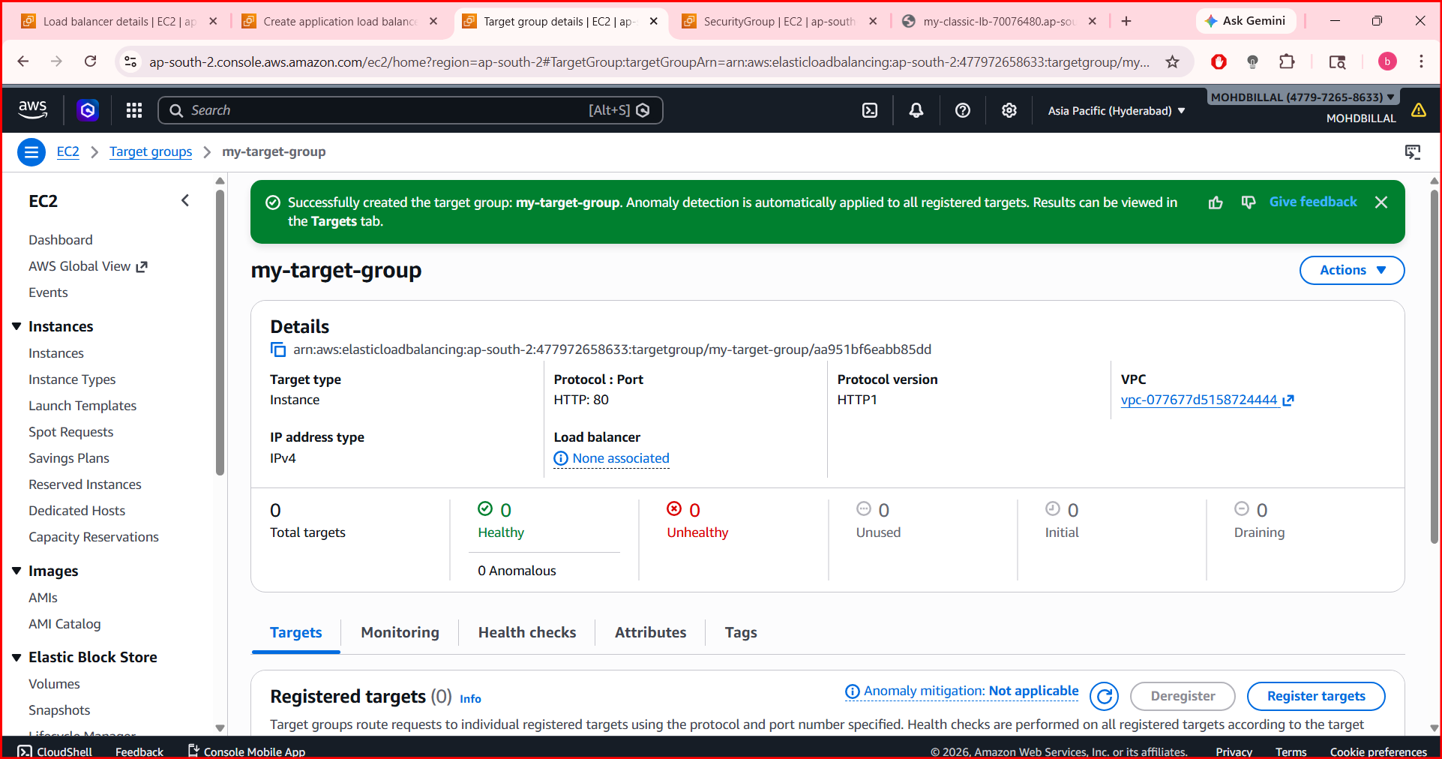
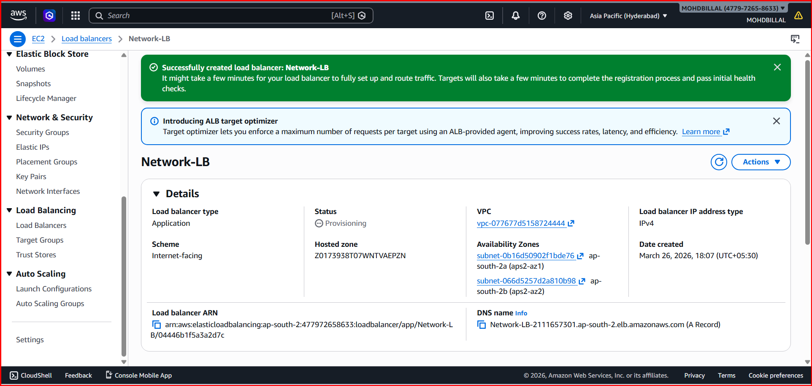
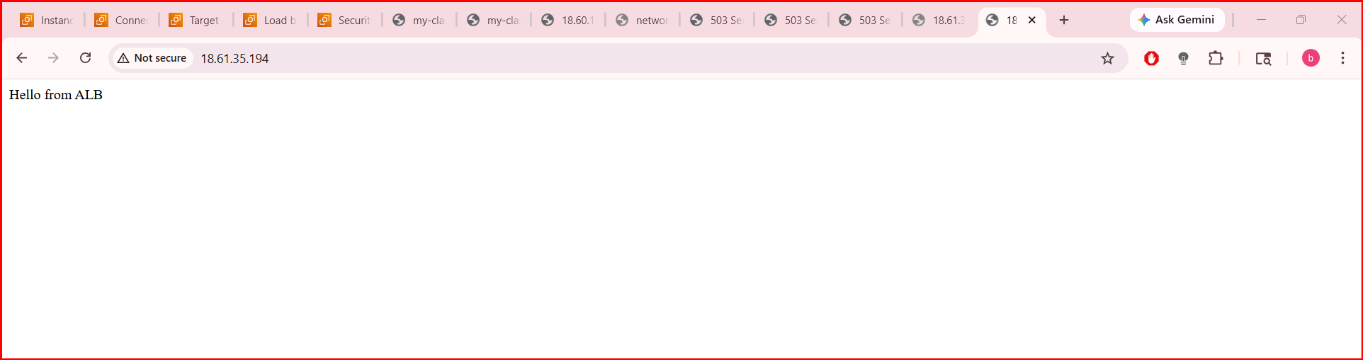
Q3. Configure Network Load balancer.

Step 1: Go to Load Balancer
- Open AWS Management Console
- Go to EC2
- Left side → Click Load Balancers
- Click Create Load Balancer

Step 2: Choose Type
- Select Application Load Balancer
- Click Create

Step 3: Basic Configuration
- Name: my-alb
- Scheme: Internet-facing
- IP type: IPv4

Listeners:
- Protocol: HTTP
- Port: 80

Step 4: Select Network
- Choose your VPC
- Select at least 2 subnets (different Availability Zones)
👉 Example:
- us-east-1a
- us-east-1b

Step 5: Security Group
Create or select one:
- Allow:
HTTP (80) → 0.0.0.0/0

Step 6: Configure Target Group
Click Create Target Group

Settings:
- Target type: Instances
- Name: my-target-group
- Protocol: HTTP
- Port: 80

Health Check:
- Path: /
- Protocol: HTTP
👉 Click Next

Step 7: Register Targets
- Select your EC2 instances
- Click Include as pending below
- Click Create Target Group

Step 8: Attach Target Group to ALB
- Go back to ALB creation
- Select your target group
- Click Create Load Balancer

Step 9: Test ALB
- Copy DNS Name of ALB
- Open in browser:
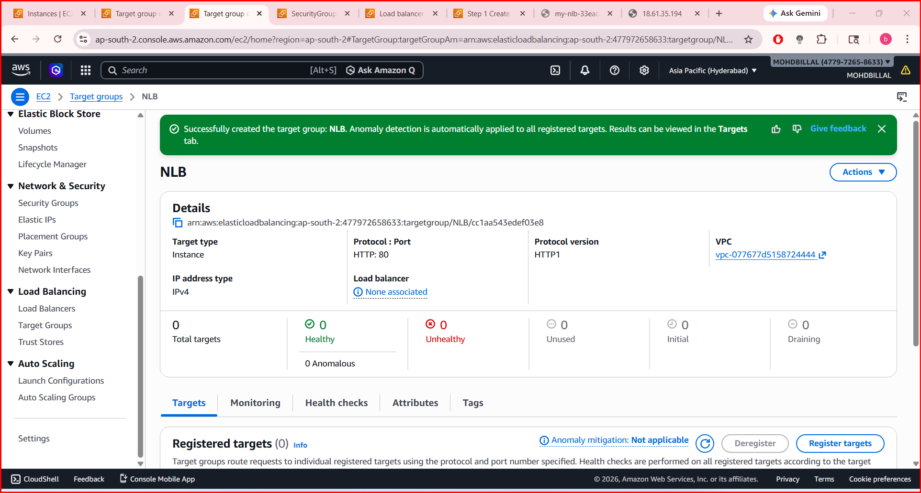
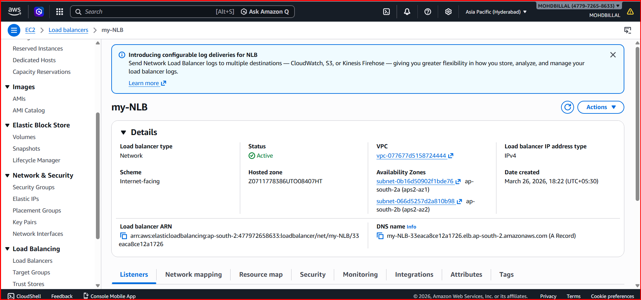

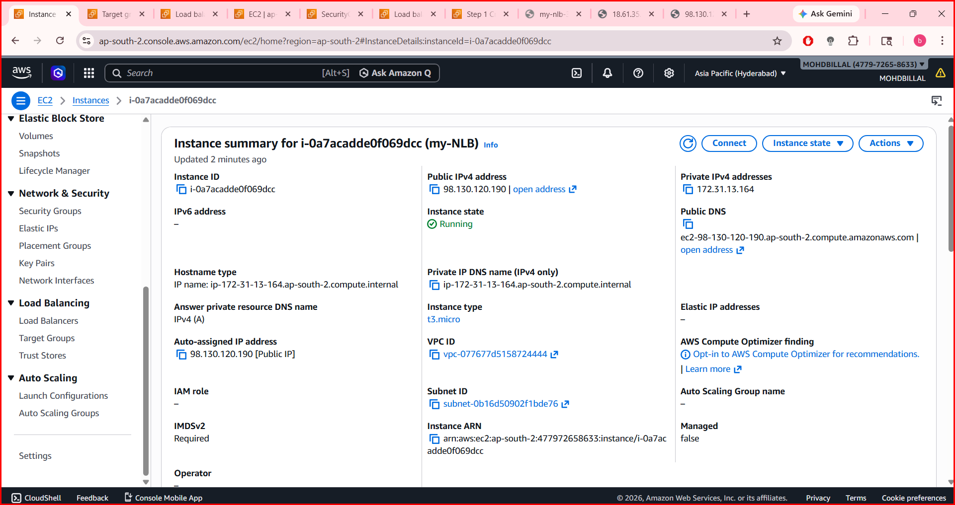
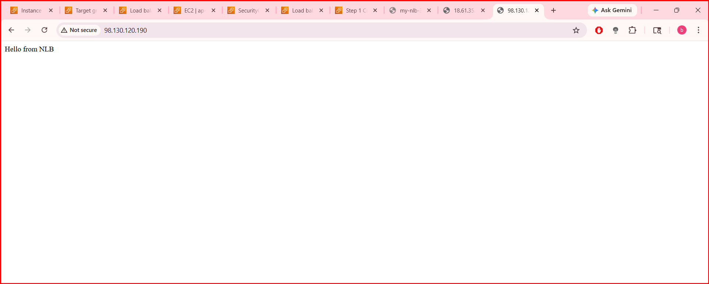
Q4 Attach SSL for application load balancer.
Q5 Map Application load balancer to R53.

Objective:
To enable secure HTTPS communication by attaching an SSL/TLS certificate to the ALB so that all incoming traffic is encrypted and securely terminated at the load balancer.
Use Cases:
- Protecting websites, APIs, and applications with HTTPS.
- Enforcing secure user login and data confidentiality.
- Offloading SSL processing from backend servers (improves performance).
- Meeting security compliance requirements such as PCI-DSS or HIPAA.
- Serving multiple secure domains using SNI (Server Name Indication).
Prerequisites
- Application Load Balancer already created.
- SSL Certificate issued from ACM or uploaded manually.
- Domain ownership verification (for ACM certificates).
- HTTPS Listener (port 443) configured on ALB.
- Security group allowing port 443 inbound.
- Correct target group for forwarding decrypted traffic.
Step by Step Implementation:
Step 1: ALB is already created

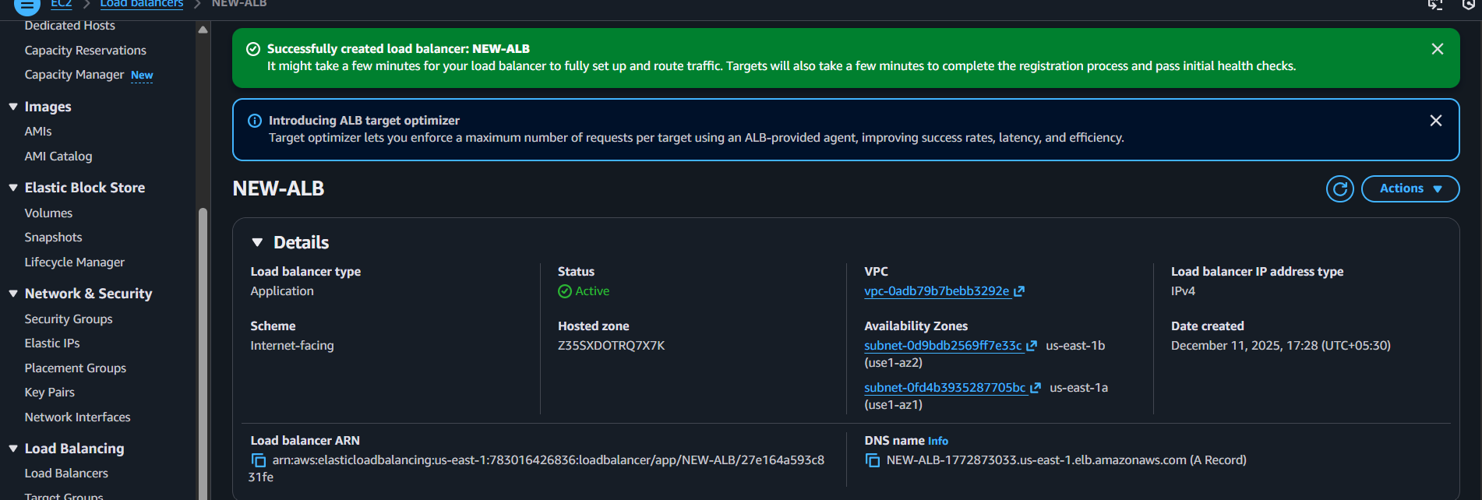

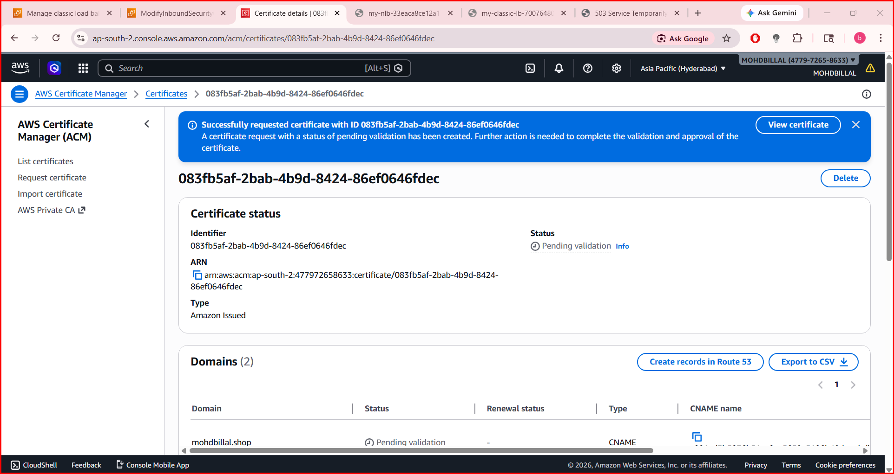

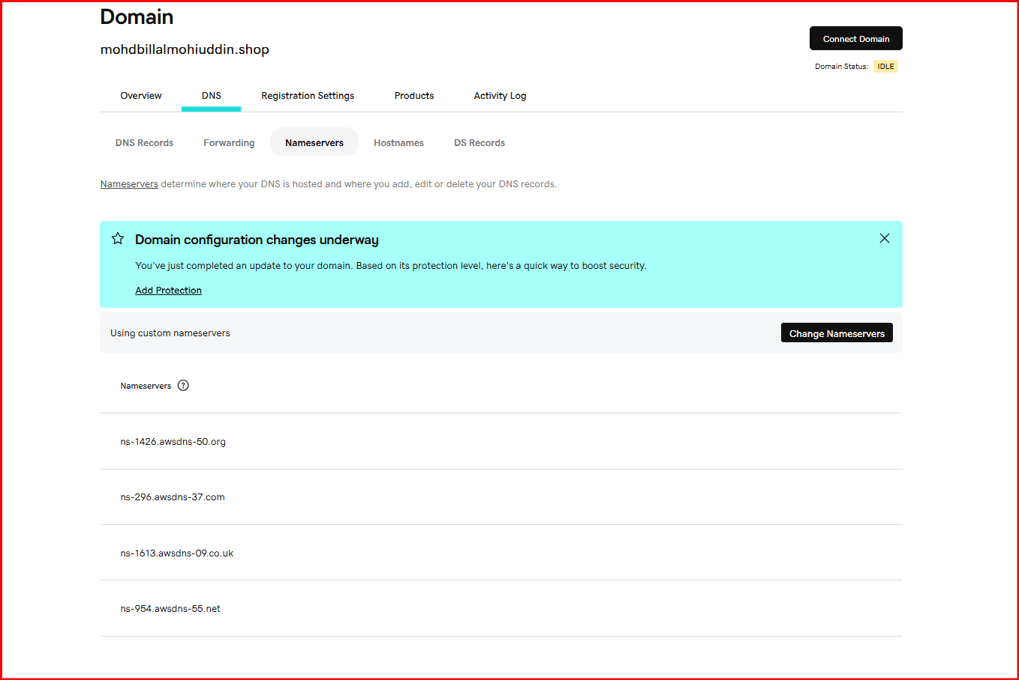
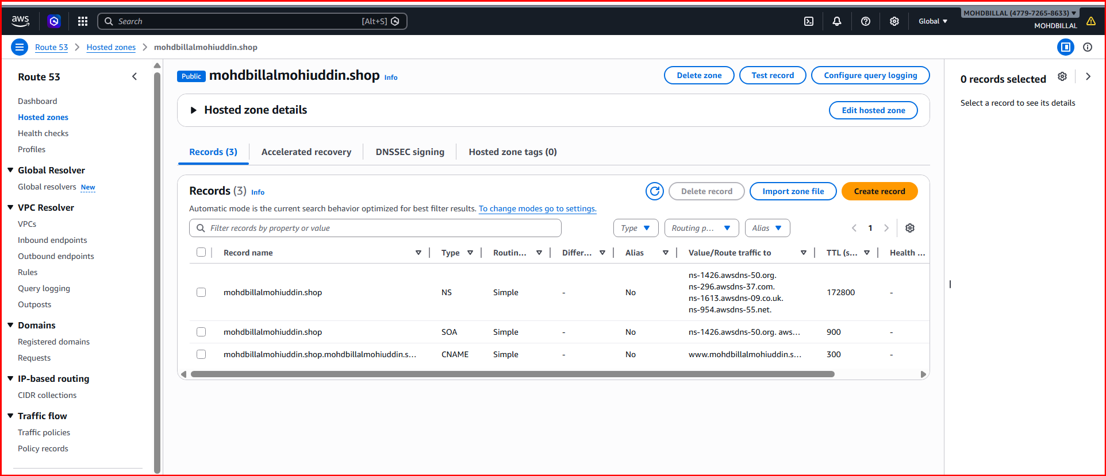
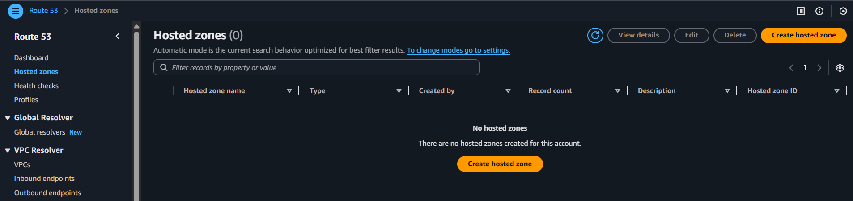
Q6 Push the application load balancer logs to S3.

Step 1: Create S3 Bucket
- Go to Amazon S3
- Click Create bucket
- Give a unique name (loadbalancerlogs18)
- Select same region as your ALB
- Keep default settings → Create bucket

Step 2: Add Bucket Policy (VERY IMPORTANT)
Go to:
S3 → Your Bucket → Permissions → Bucket Policy
{
"Version": "2012-10-17",
"Statement": [
{
"Sid": "AllowALBWrite",
"Effect": "Allow",
"Principal": {
"Service": "logdelivery.elasticloadbalancing.amazonaws.com"
},
"Action": "s3:PutObject",
"Resource": "arn:aws:s3::: loadbalancerlogs18/*",
"Condition": {
"StringEquals": {
"s3:x-amz-acl": "bucket-owner-full-control"
}
}
},
{
"Sid": "AllowALBReadACL",
"Effect": "Allow",
"Principal": {
"Service": "logdelivery.elasticloadbalancing.amazonaws.com"
},
"Action": "s3:GetBucketAcl",
"Resource": "arn:aws:s3::: loadbalancerlogs18"
}
]
}

Step 3: Enable Logs in ALB
- Go to Amazon EC2
- Click Load Balancers
- Select your Application Load Balancer
- Go to Attributes
- Click Edit
- Enable:
  - Access Logs
  - Select your S3 bucket
  - (Optional) add prefix: alb-logs
- Click Save changes

Step 4: Verify Logs
After 5–10 minutes:
Go to:
S3 → your bucket → AWSLogs → account-id → elasticloadbalancing
